H.T No
Regulations:
A18

Sreenidhi Institute of Science and Technology
(An Autonomous Institution)
Code No: 7K719 Date: 17-Jan-2023 (FN)

B.Tech IV-Year I- Semester External Examination, January-2023 (Regular & Supplementary)
ESTIMATION, COSTING AND VALUATION (CIVIL)

Time: 3 Hours Max.Marks:70

Note: a) No additional answer sheets will be provided.
b) All sub-parts of a question must be answered at one place only, otherwise it will not be valued.
c) Missing data can be assumed suitably.
Bloom's Cognitive Levels of Learning (BCLL)

Remember | L1 | Apply | L3 | Evaluate | L5
Understand | L2 | Analyze | L4 | Create | L6

Part - A Max.Marks:20

Answer all QUESTIONS.
 |  | BCLL | CO(s) | Marks
1 | What are the units for estimating the quantities of brickwork and plastering? | L1 | CO1 | [2M]
2 | Find out the proportions of various materials required to prepare a 1 cu.m. of 1:3:6 concrete? | L2 | CO2 | [2M]
3 | What are the advantages of item rate contract? | L2 | CO3 | [2M]
4 | What should be mentioned in a bar bending schedule? | L2 | CO4 | [2M]
5 | Define contract? Give the objects of contract. | L1 | CO5 | [2M]
6 | Explain in brief the process of bidding. | L2 | CO6 | [2M]
7 | Calculate the quantity of earthwork for 200 metre length for a portion of a road in a uniform ground the heights of the banks at the two ends being 1m and 1.6 m. The formation width is 10 metre and side slopes 2:1. Assume there is no traverse slope | L3 | CO1 | [2M]
8 | Why does you provide the shuttering in the structure | L2 | CO4 | [2M]
9 | Write the purpose of valuation? | L1 | CO6 | [2M]
10 | List the factors affecting rate analysis | L1 | CO3 | [2M]

Part – B Max.Marks:50
ANSWER ANY FIVE QUESTIONS. EACH QUESTION CARRIES 10 MARKS.

 |  |  | BCLL | CO(s) | Marks
11. |  | Prepare an approximate estimate of building project with total plinth area of all building is 800 sqm. and from following data.  i) Plinth area rate Rs. 4500 per sqm  ii) Cost of water supply @7½%of cost of building.  iii) Cost of Sanitary and Electrical installations each @ 7½% of cost of building.  iv)Cost of architectural features @1% of building cost.  v) Cost of roads and lawns @5% of building cost.  vi) Cost of P.S. and contingencies @4% of building cost.  Determine the total cost of building project. | L5 | CO1 | [10M]
12. |  | The formation width of a road embankment is 15m. The side slopes are 2:1. The depths along the centre line of road at 100.0 m intervals are 1.20, 1.30, 1.40, 1.60, 0.70, 1.5 and 1.0. Calculate the quantity of earth work by (i) Trapezodial rule and (ii) Prismoidal rule | L3 | CO2 | [10M]
13. | a) | Carry out the rate analysis for 1:2:4 RCC work for beams. | L4 | CO3 | [5M]
 | b) | Find out dry materials for 1 cu m lime concrete. | L4 | CO3 | [5M]
14. | a) | Estimate the amount of reinforcement and prepare bar bending schedule for the beam given below. Assume cover as 40 mm and assume necessary data if needed.  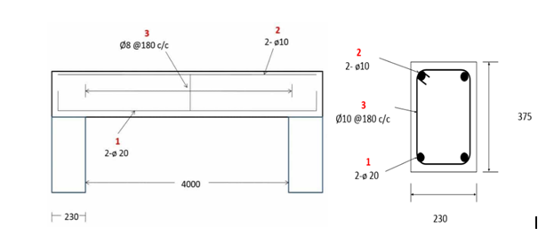 | L2 | CO4 | [5M]
 | b) | Discuss general guidelines to be followed for preparing BBS. | L2 | CO4 | [5M]
15. | a) | Discuss in detail about (i) Cost plus fixed fee contract (ii) Item Rate contract | L2 | CO5 | [5M]
 | b) | Explain various special contracts. |  | CO5 | [5M]
16. | a) | The gross rent through a property is Rs 50,000 per annum. Allowing 15% for deductions for repairs, maintenance and management of property. Estimate rental value of property at an interest rate of 10% and 12% assuming the rent to be realized for long period. | L2 | CO6 | [5M]
 | b) | Discuss in detail about various methods of Valuation and Depreciation. | L2 | CO6 | [5M]
17. | a) | What is the purpose of estimating? | L1 | CO1 | [4M]
 | b) | What is the condition for using prismoidal rule in earthwork estimation? | L1 | CO2 | [3M]
 | c) | How much contractor's profit is generally considered for rate analysis? | L2 | CO3 | [3M]
18. | a) | Discuss about shuttering material requirements and schedules. | L2 | CO4 | [4M]
 | b) | What is sub-contracting? |  | CO5 | [3M]
 | c) | Differentiate between scrap value and salvage value. | L2 | CO6 | [3M]

-- 00 -- 00 –

